Chapter 7, Problem 42.

(a) If the switch in Fig. 7.109 has been open for a long time and is closed at t = 0, find v_{o}(t).

(b) Suppose that the switch has been closed for a long time and is opened at t = 0. Find v_{o}(t).

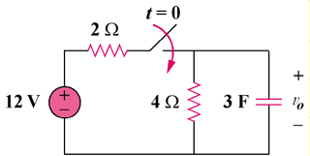

Figure 7.109
For Prob. 7.42.

